Section 1: Calculator Free Time: 40 mins Marks: 35
Section 2: Calculator Assumed Time: 20 mins Marks: 15 TOTAL: 50 marks

Name:___________________________
Section 1: Resource Free

Question 1 (7 marks)
Differentiate the following functions and simplify using positive indices where appropriate:
(a) y = -4x³ + 2x² + 3 (b) f(x) = (x + 1)² (c) 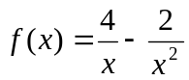

(d) y = 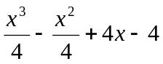

Question 2 (4 marks)
Apply the limiting chord theorem (differentiate using first principals) to the function f(x) = 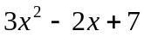 to show how the gradient becomes f’(x) = 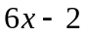. Show all working.

Use: Gradient of f(x) = 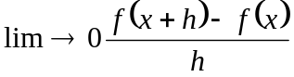

Question 3 (5 marks)

a) Determine the gradient of 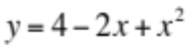 at the point (-3,5)

b) Find the equation of the tangent to 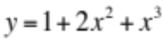 at the point (-2, 4).

Question 4 (6 marks)

The temperature T (ºC) of a body varies with time t (seconds) and is given by 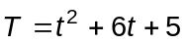.

(i) What is the initial temperature of the body?

(ii) Find the average rate of change of temperature of the body between 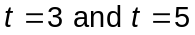

(iii) Calculate the instantaneous rate of change of temperature of the body when 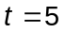

Question 5 (8 marks)

Consider the cubic function 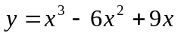 over the domain -1 ≤ x ≤ 4

- Use calculus techniques to find the location and nature of the stationary points.

- Find the x intercepts

- Graph the function over the given interval
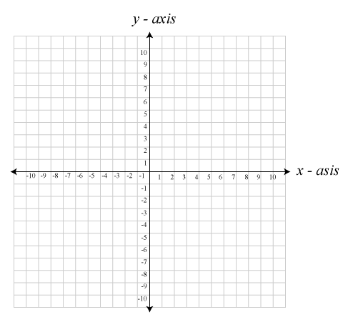

Question 6 (5 marks)

A body is projected from an origin 0 and moves in a straight line such that
its displacement from 0, t seconds after projection is given by
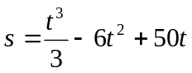

- How far is the body from the origin after 3 seconds?

- Find an expression for the velocity of the body t seconds after projection.

- What is the initial velocity of the body?

- For what value of t is the body moving with minimum velocity and how far from 0 is the body at
this time?


Unit 2

57
Semester 2 2017
Mathematics Methods Test 2

Resource Assumed
Question 7 (8 marks)

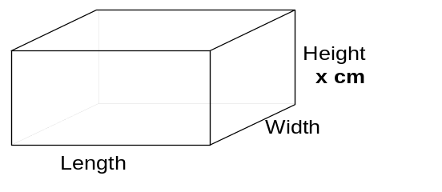
A piece of wire, 2⋅4m long, is used to make
the 12 edges of the frame of a rectangular
box. The height (x cm) of the frame must be
half the length of the frame.

a) Express the length of the frame in terms of x.

b) Remembering that the total length of wire is 240cm, find the width in terms of x.

c) Find the volume of the box in terms of x.

- Find.correct to one decimal place, the three dimensions (height, length and width)
that will give the maximum volume for the box.

Question 8 (7 marks)

To manufacture x items costs a company 40x + 15 000 dollars.
The company has set a sale price of 150 – 0.02x dollars per item.
Find:

    - the number of items that should be produced for maximum profit.

    - The price per item to achieve the maximum profit.

End of Test

